Use Cases for the Architecture for Climate Monitoring from Space
Background
The World Meteorological Organization (WMO) and the joint CEOS/CGMS Working Group on Climate are collecting Use Cases to support the Architecture for climate monitoring from space. These Use Cases will be reviewed by subject matter experts before publishing online. Examples of Use Cases are available at https://climatemonitoring.info/use-cases/.
You are kindly invited to submit use cases using this template. Please prepare your case by answering all applicable questions and send your contributions to Dr. Wenying Su (Wenying.Su-1@nasa.gov) and Dr. Zoya Andreeva (zandreeva@wmo.int).

Submission of Use Case

- Organization/entity proposing the Use Case:

- Name and email contact details of focal point for the Use Case:
Name:
Country:
Email Address:

- Title of the Use Case:

- Key points (up to three) of the Use Case:

- Please indicate the Service/Thematic Area(s) of the Use Case (double click on the boxes to check them):

Adaptation | Fisheries | Mitigation
Agriculture | Flood management | Protocol monitoring
Coastal management | Food security | Tourism
Disaster risk reduction (DRR) | Health | Urban
Energy | Marine ecosystems
Other (specify below)

Other:

- Please indicate the end user(s) category of the Use Case. Select “Other (describe)” if none of the listed categories is applicable (double click on the boxes to check them):

General Public | Local communities | Researchers
Government agencies | Policymakers
Industry | Reef managers
Other (describe below)

Other:

6. Please list the intermediate user(s) (specify):

7. Please briefly describe the Use Case application(s) (specify):

8. Please indicate the GCOS Essential Climate Variables used in your Use Case:
(A detailed description of the GCOS Essential Climate Variables can be found here.)

8a. Essential Climate Variables---Atmosphere (double click on the boxes to check them)
 | Aerosols |  | Ozone |  | Temperature
 | Carbon dioxide, methane and other greenhouse gases |  | Precipitation |  | Water vapour
 | Clouds |  | Precursors for aerosols and ozone |  | Wind speed and direction
 | Earth radiation budget |  | Pressure
 | Lightning |  | Radiation budget

8b. Essential Climate Variables---Land (double click on the boxes to check them)
 | Above-ground biomass |  | Fraction of absorbed photo-synthetically active radiation (FAPAR) |  | Land surface temperature
 | Albedo |  | Glaciers |  | Leaf area index
 | Anthropogenic greenhouse gas fluxes |  | Groundwater |  | River discharge
 | Anthropogenic water use |  | Ice sheets and ice shelves |  | Snow
 | Evaporation from land |  | Lakes |  | Soil carbon
 | Fire |  | Land cover |  | Soil moisture

8c. Essential Climate Variables---Ocean (double click on the boxes to check them)
Inorganic carbon | Plankton | Sea surface temperature
Marine habitats | Sea ice | Subsurface currents
Nitrous oxide | Sea level | Subsurface salinity
Nutrients | Sea state | Subsurface temperature
Ocean colour | Sea surface currents | Transient tracers
Ocean surface heat flux | Sea surface salinity
Oxygen | Sea surface stress

9. Please briefly list the models used in your Use Case. Provide references and links as may be applicable:

10a. Are the climate data records used in your Use Case already listed in the ECV Inventory?
Yes
No

10b. Please list the climate data records used in your Use Case. Provide RecordID in the ECV Inventory where applicable:

11. Please indicate the agencies/organizations that produce the relevant Essential Climate Data records used in your Use Case:

12. Please list the satellite observations (e.g. NOAA AVHRR, Sentinel 1..) used in your Use Case：

13. Please briefly comment on the sustainability of your service/Use Case (demonstration, operational, …):

14. Please copy below the full description of your Use Case (600-1500 words and up to four figures) (for examples see https://climatemonitoring.info/use-cases/)

15. Each Use Case will be described using a graphical depiction of the Information Flow in line with the Architecture for Climate Monitoring from Space, please provide text for the four boxes in accordance with the graphical examples depicted below (please provide succinct inputs for the graphical depiction in bullet forms) :
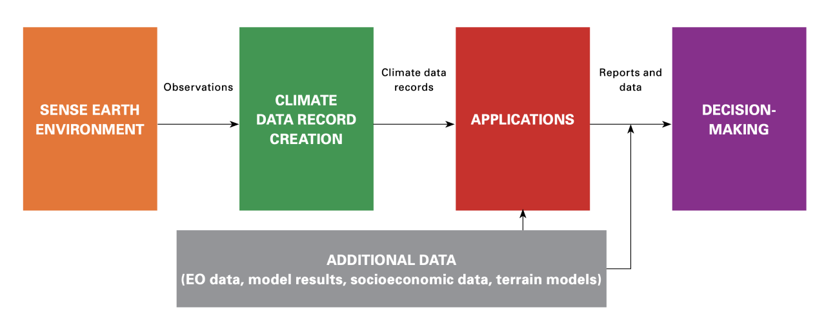
Example:
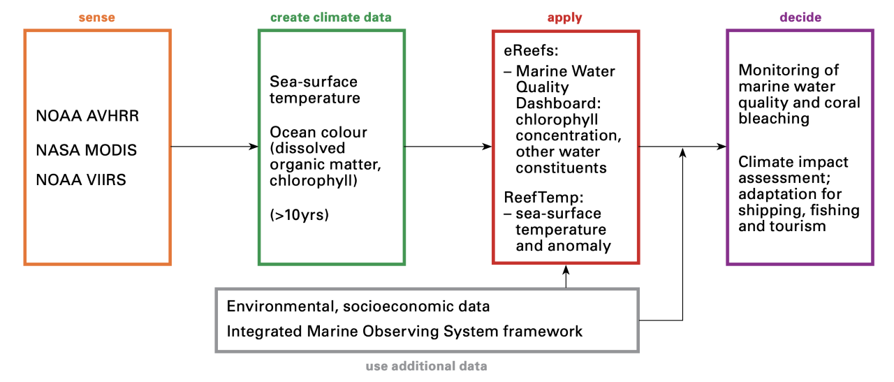

15a. Sensing - describe the sensing component (Pillar I): (up to 5 bullets)

15b. Climate Data Records- describe the climate data records used (Pillar II): (up to 5 bullets)

15c. Application - describe the application/products (Pillar III): (up to 5 bullets)

15d. Decision making - describe the decisions that can be taken based on the application (Pillar IV): (up to 5 bullets)

16. Indicate how the Use Case could be improved and what data/tools could help in this regard:

17. Provide 1-4 high quality images (vector files such as .ps and .eps are preferred, for .png or .jpg files 300 dpi resolution is preferred) supporting the Use Case description (see 14):
Attach Figure 1

Figure 1 caption:

Attach Figure 2

Figure 2 caption:

Attach Figure 3

Figure 3 caption:

Attach Figure 4

Figure 4 caption:

